
BEN CLOWARD – Character Animator & Technical Artist

ANIMATION REEL DESCRIPTION

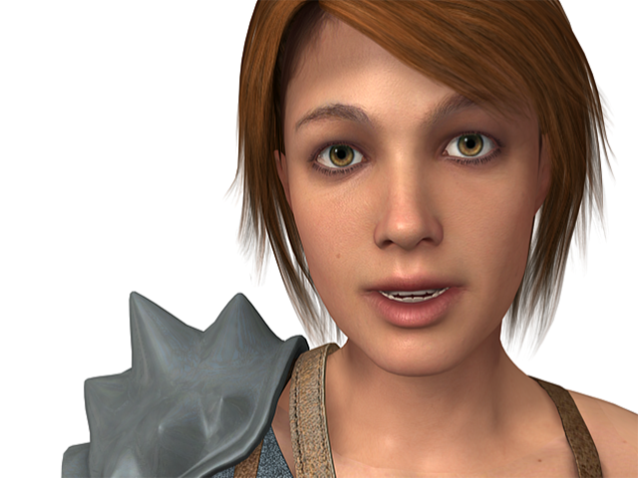
Atlantis Demo Facial Animation 00:06 - 00:12
This character was modeled and textured by Steven Giesler with target specs for PS3 and Xbox 360. I created the materials, the lighting, and the animation for this clip as part of a video used by our company at GDC 2007 to sell our game engine. We also used this character in our next-gen engine demo.

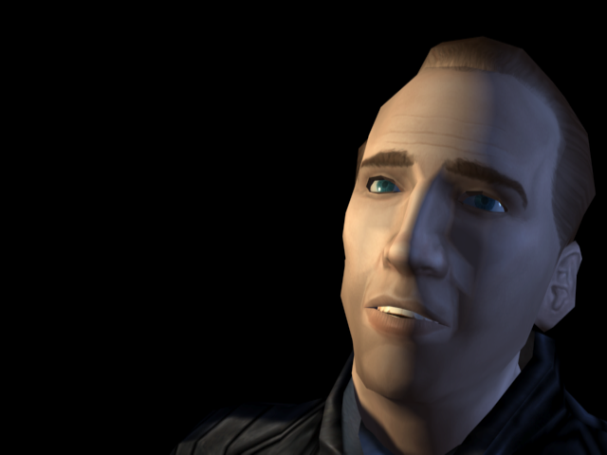

Nicholas Cage Facial Animation Test 00:12 - 00:33
I animated this sequence to test the facial rigging system that I developed for our company. This system uses morph targets to represent various facial muscle groups. It allows for a wide variety of facial expressions using as few targets as possible which gives better real-time performance and accommodats game engine limitations. I used video footage as reference while animating this sequence. I did not make the base model or paint the textures.

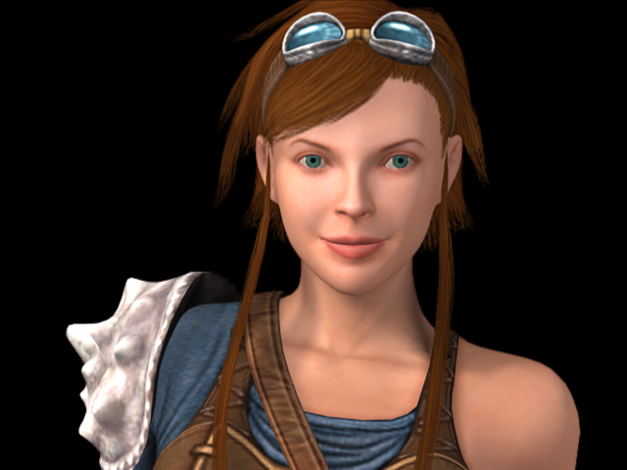
Atlantis Demo Facial Animation 2 00:33 - 00:38
This version of the Atlantis character was modeled and textured by Brian Jones (Bobo the Seal) with target specs for the PS2. I created the facial rig for this character and animated this clip as part of a video that was shown at our company's GDC 2006 booth.

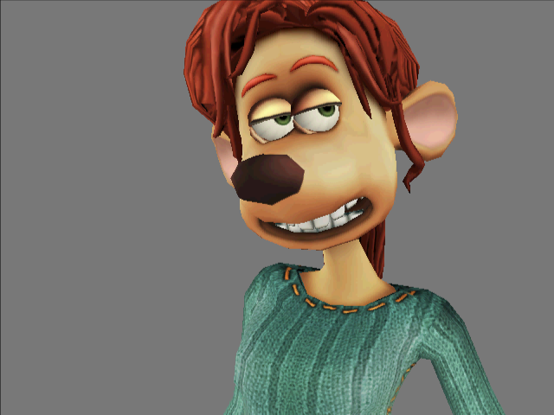
Flushed Away – Rita Facial Animation 00:38 - 00:47
For Rita's facial rig, I created morph targets that matched the exaggerated shapes of the movie character. The facial animation was done in a sharp, poppy style that mimics Aardman Animation's stop-motion look. I created this clip as a test – both for my facial rig and also to show our publisher that we could achieve the same quality level of expressive characters on the PS2 that Dreamworks and Aardman were creating for the film.

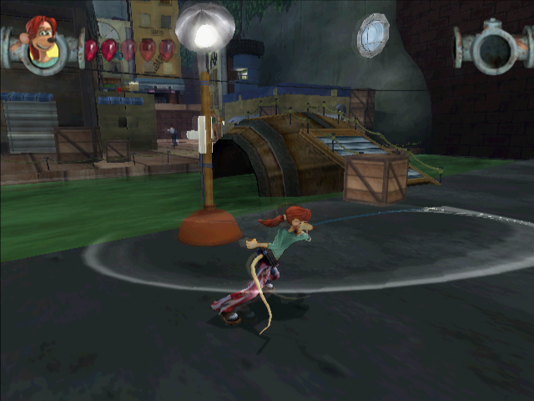
Flushed Away – Rita In-Game Animation 00:47 - 01:36
This sequence of shots shows off some of my favorite in-game animations that I created for Rita, one of two main characters in the game. I rigged and animated Rita and created the motion blur effects in her fast movements. The model and textures were created by Rob Maxwell. I did not contribute to the environments that are shown in these shots. As lead animator, I was excited when the game received an Annie Award for “Best Animated Video Game of 2006.”
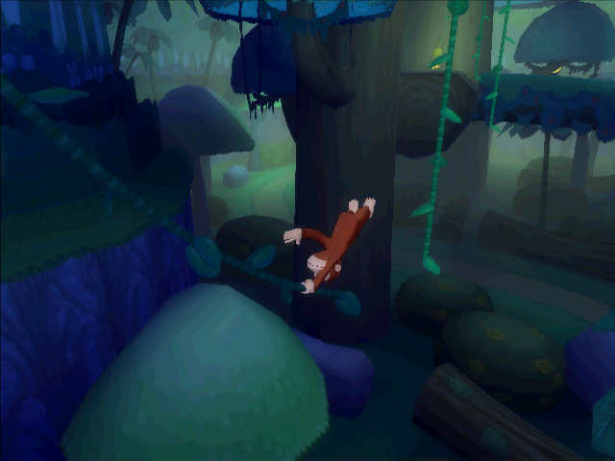
Curious George 01:36 - 1:59
For this project, I rigged and animated George, the main playable character. Creating monkey animations is fun! This portion of the reel shows some of the animations I created in action in the game. During this project I began the development of my automated character rigging script which now allows our animators to set up characters in about 15 minutes instead of the usual 2 days of rigging. I did not contribute to the environments that are shown in these shots.
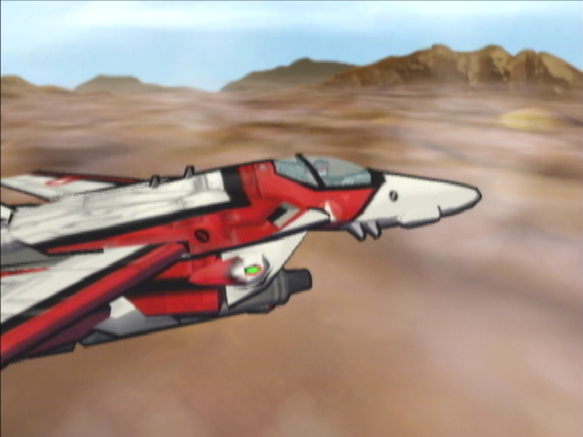

Transformable Veritech Fighter from Robotech: Battlecry 1:59 - 2:24
Designing a rig that would allow this character to be easily animated in three different modes and also transform between them was a thrill for me. I created all of the animations for this main character and worked with others to create the model. I did not paint any of the textures.

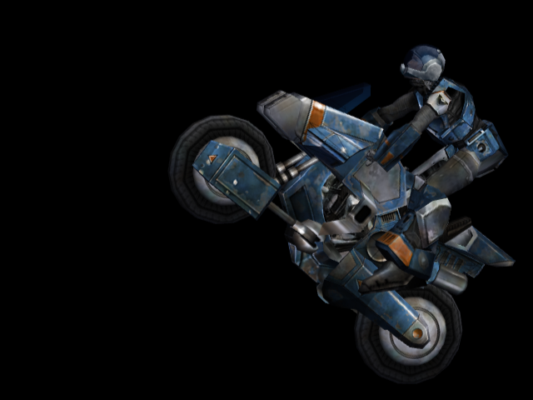
Transformable Cyclone Ride Armor and Rider from Robotech: Invasion 2:24 - 2:42
I created the models of both the rider and the transformable cyclone motorcycle and developed a rig which allowed them to animate and transform. The two models acted together as one when in armor mode, the parts of the armor acting as children to the body parts of the rider. When in cyclone mode, the rider acted as a child of the bike. Finally, my rig allowed the rider to leave the bike and go on foot. This same rig was used in both first person perspective and third person perspective during game play.

